Bundled Products and Simple Products Descriptions

Solution: Change product type from bundled to group product

If we do it this way, we will need to be able to create a new group product from the current product, then transfer the generic description and other field info from the “General” tab of the current bundled product. Move it into the new group product fields, then check off in “associated products” tab the other products that are included with this.

Once this is done, we will have to disable or delete the bundled product, and once that’s done, the specific simple product details will show rather than the default ones from the bundled product.

Going to add screenshots

1.)

We will be using an example here: PLJW Bundle Test

It bundles the two products PLJW 185.30 and also PLJW 185.36

We will need to get all of the values in those fields in the general tab

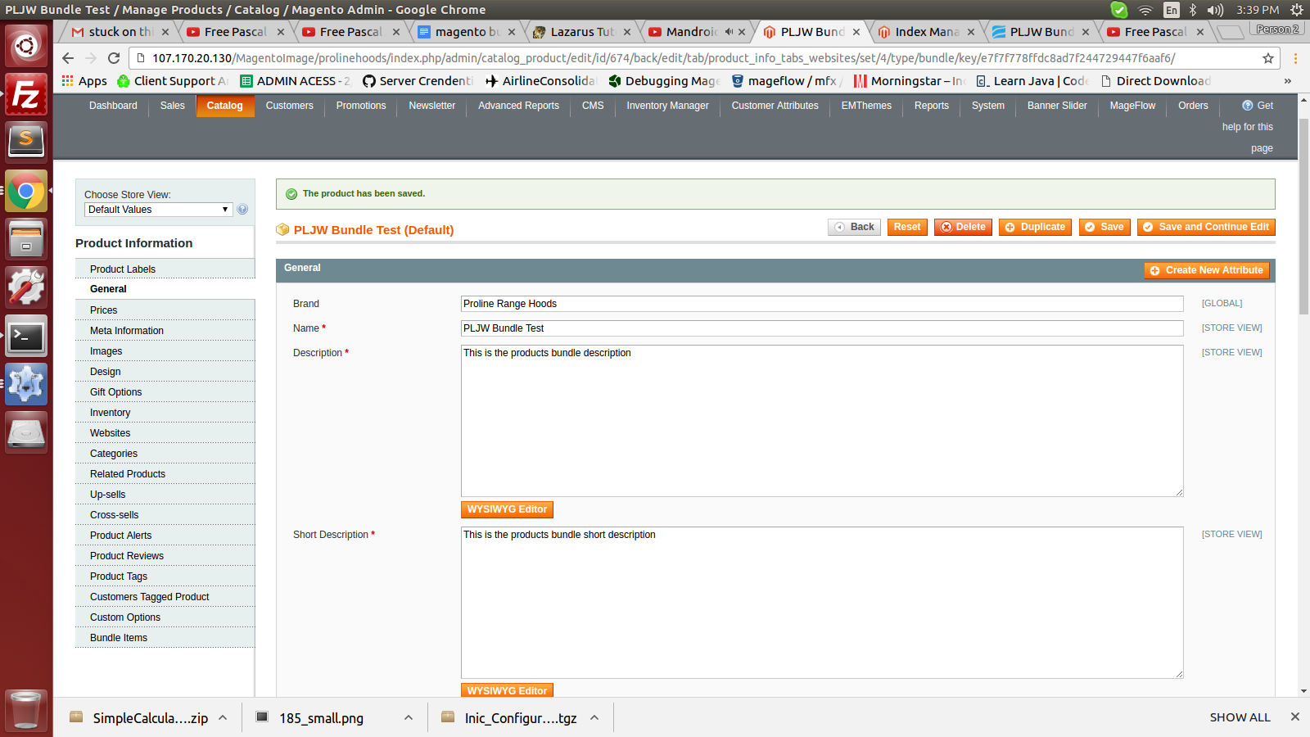

2.)

Create a new product with product type ‘group’

PLJW 185 test is the new grouped product

You can see how the other associated products are included

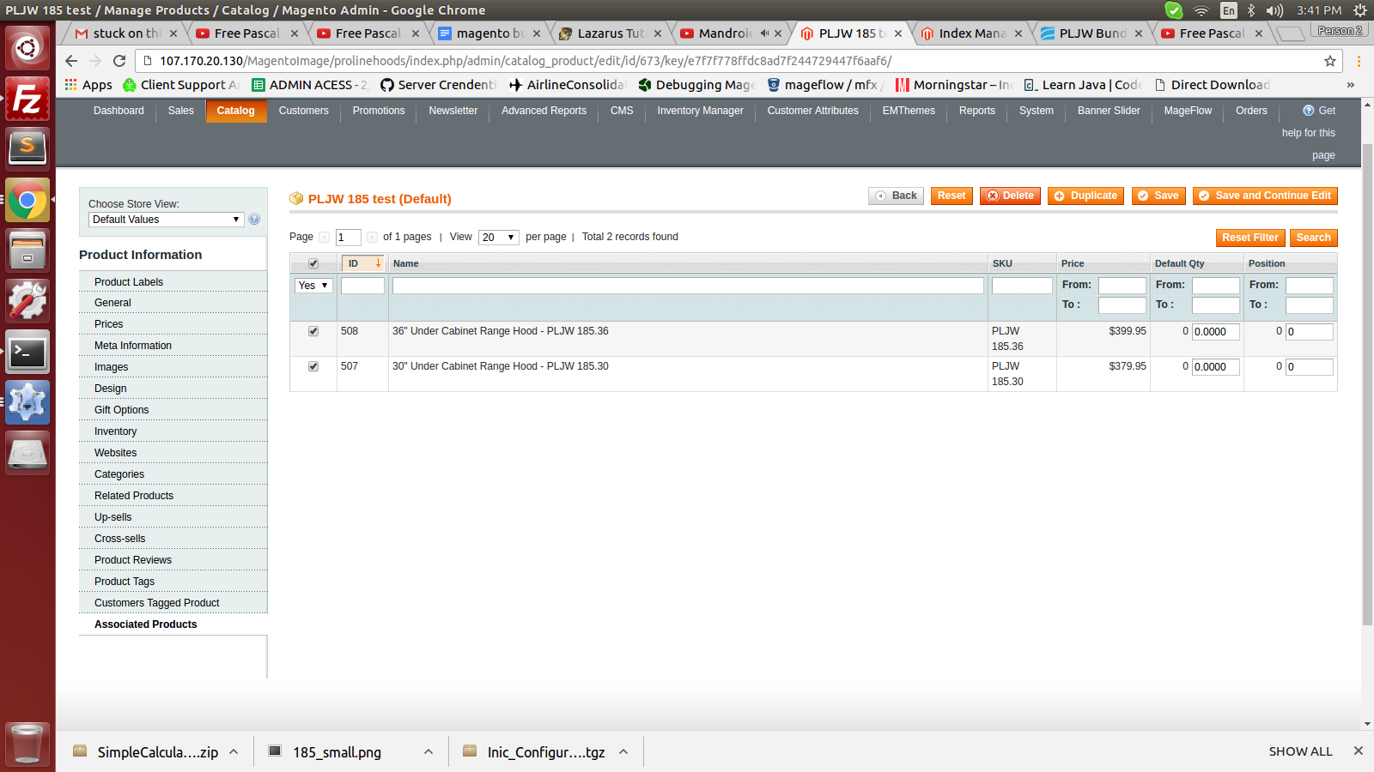

Once that is done and everything is setup, you will need to disable the “Default” setting for most of the description fields within the simple products associated with it, we will only be changing things related to the flagship (on dev) or venthoodpro (on live) so always have the proper scope selected.

Once this is all done and you’ve got pages for each simple product associated with the group product with all the right information, then you can add the new url for that product to the google doc with all the new 301 redirects in it

Solution that will require php :::::

_______________________________________________________________________

Any product that is going to have it’s own URL will need to be able to have it’s own exact descriptions. For example:

PLJW 185 bundled product has it’s own default descriptions

There are multiple sizes of this product.

Because of how ZenCart was setup, each size of each model product had its own page

In order to comply with googles standards a 301 redirect will have to be create for every, single size of every product that is included in google’s list.

Currently when I have the simple PLJW 185.30 (30 inch version of this model) and it’s url is :

/30-under-cabinet-range-hood-pljw-185-30.html

That is the url for the specific size of that model, but it still shows all the information of the bundled parent product. I’ve searched but there is no simple solution like there would be for “grouped” or “configurable” products.

We need the values that are stored in the PLJW 185.30 “description” “short description” and any of the other areas that might be different and more relevant to the current size to show up, rather than the default ones for the parent bundle.

I need this functionality done before I can continue creating new product pages for specific sizes in order to satisfy googles requirements.

You can work on this on the test site 107

<http://107.170.20.130/MagentoImage/flagship/index.php/30-under-cabinet-range-hood-pljw-185-30.html> is the url for the example model.

Please include all changes made and to which files so that I can implement it on the live site when it comes time.